Test Case for serialisation

Requirement to test | Test Data Input | Expected Outcomes | Actual Outcomes
- Save objects to file | Run Program | 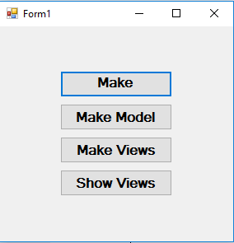 | As expected
 | Run the program and add four objects | 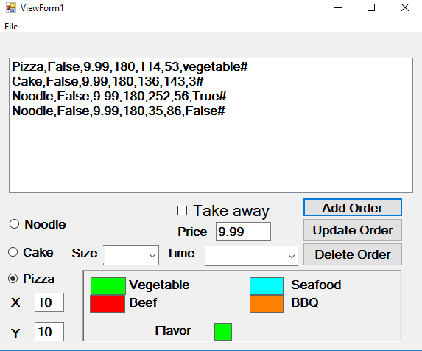 | As expected
 | Press ”File” menu, select “save” | 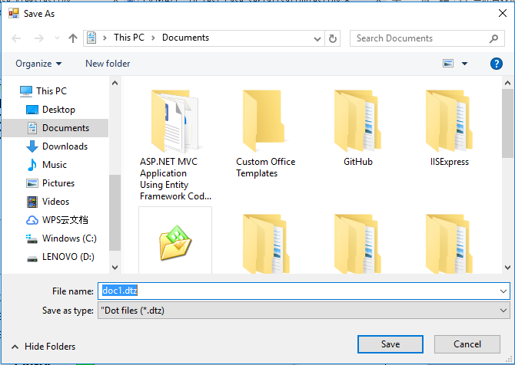 | As expected
 | Press “save” on the dialog pumped out | A dtz file has been saved, which contains the attributes of the four objects. The objects order in the dtz file is the same with the order in the view. | As expected
- load objects from file | Run Program |  | As expected
 | Run the program and add four objects | View 1,view 2 ,view 3 show correctly | As expected
 | In view1, click menu “File”,then select “open” | 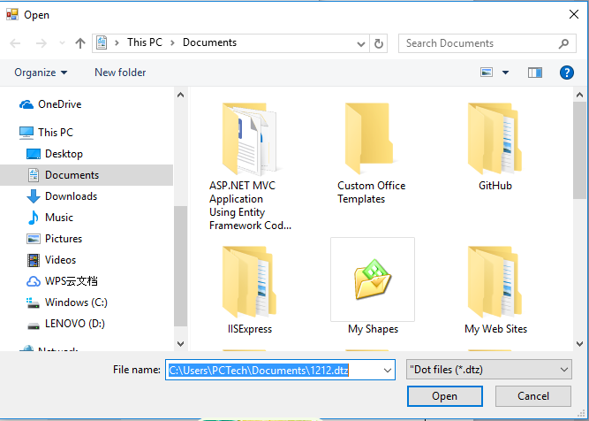 | As expected
 | Select a target dtz file in the open file dialog | Objects are loaded correctly, and their order is the same as the order in the dtz file.  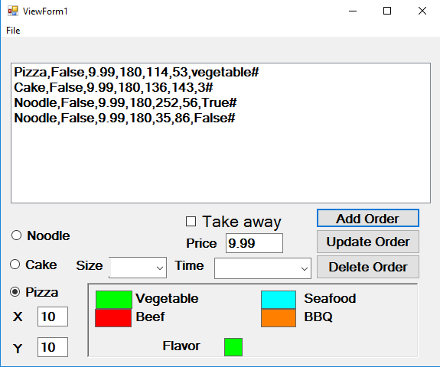 | As expected

